Ch. Ainsley’s Double Agent  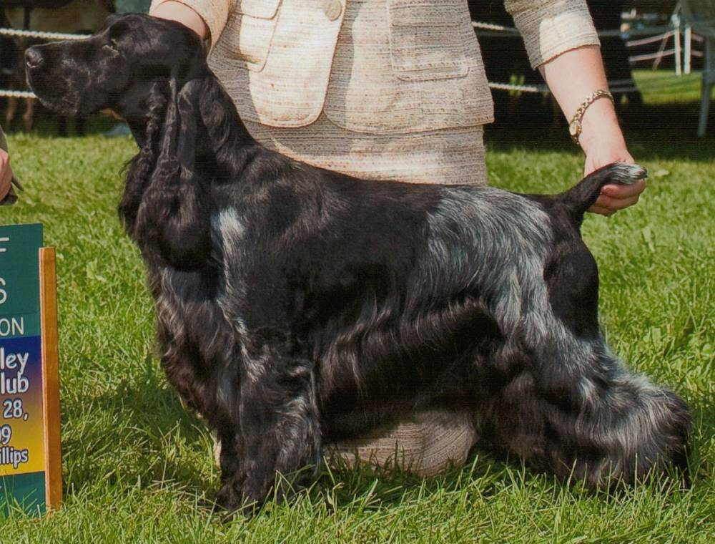 | Ch Ivywood Double Jeopardy | Ch. Ainsley Boxhill Back N Black | Ch. Boxhill’s Blackjack | Ch. Bellfower Boxhill Jackpot
 |  |  |  | Ch Boxhill’s Bewitched
 | Ch Ivywood Double Jeopardy | Ch. Ainsley Boxhill Back N Black | Ch. Ainsley’s Back Talk | Ch. Amawalk Wildwood Honor Guard
 |  |  |  | Ch. Kedgwick Goodtime Charlie CD
 | Ch Ivywood Double Jeopardy | Ch. Ainsley’s Perfect Krime | Ainsley’s Taylor McMurphy | Ch Kedgwick Split Decision
 |  |  |  | Ch. Ainsley’s Cara Of Gold Leaf
 | Ch Ivywood Double Jeopardy | Ch. Ainsley’s Perfect Krime | Ch. Portrait’s Ainsley Blu Lace | Ch Kedgwick Split Decision
 |  |  |  | Ch. Majick Annie’s In The Pink
 | Ch. Ainsley’s Lucky Charm | Ch. Portrait Ivywood Middnight Sun | Ch. Sunnyside Skylark Play By Play | Ch. Daisymead’s Playboy
 |  |  |  | Ch. Sunnyside Starry Night
 | Ch. Ainsley’s Lucky Charm | Ch. Portrait Ivywood Middnight Sun | Ch. Ainsley Portrait Badd Desire | Ch. Brasswind’s Windem Rainman
 |  |  |  | Ch. Barrister Ainsley High Style
 | Ch. Ainsley’s Lucky Charm | Ch. Faerytail’s Leprechaun | Ch Ashbrook Aristocrat | Ch. Lynann’s Telesis
 |  |  |  | Ch. Headwind’s Kittyhawk
 | Ch. Ainsley’s Lucky Charm | Ch. Faerytail’s Leprechaun | Ch. Royal Crest Dreamcatcher | Ch. Berridale’s Dream Come True
 |  |  |  | Ch. Stage Door Skylark Finale
Ch. Ainsley’s American Girl  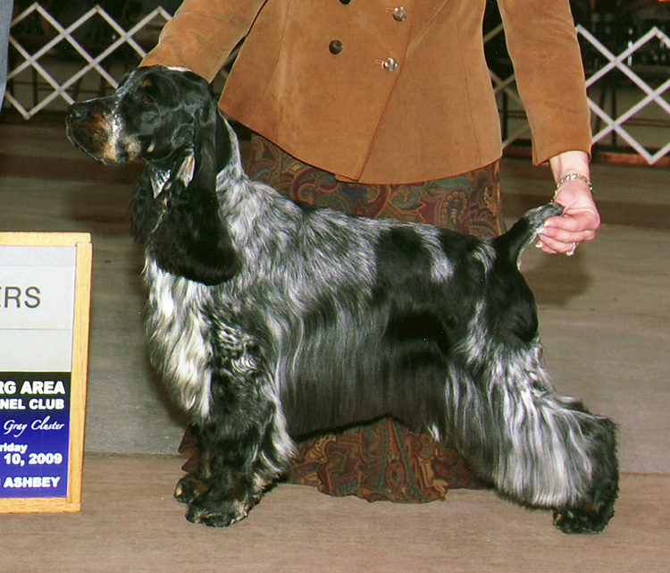 | Ch. Spring Run Ivywood’s Good To Be King CD RE NA OAJ NAP NJP OF | Ch. Portrait Ivywood Middnight Sun | Ch. Sunnyside Skylark Play By Play | Ch. Daisymead’s Playboy
 |  |  |  | Ch. Sunnyside Starry Night
 |  | Ch. Portrait Ivywood Middnight Sun | Ch. Ainsley Portrait Badd Desire | Ch. Brasswind’s Windem Rainman
 |  |  |  | Ch. Barrister Ainsley High Style
 |  | Ivywood Spring Run Original Sin | Ch. Songbird’s Gotta Dance | Ch. Stardust Cimarron
 |  |  |  | Ch. Lynann’s Love Song
 |  | Ivywood Spring Run Original Sin | Ch. Ainsley’s Blue By You | Ch. Daisymead’s Birth Of The Blues
 |  |  |  | Ainsley’s Fine Lines
 | Ch. Ainsley’s Jersey Girl | Ch. Amawalk Dunelm Clansman | Ch. Amawalk’s Easy Care Bear | Ch. Carachelle Cattleman
 |  |  |  | Ch. Amawalk’s Xecutive Miss
 | Ch. Ainsley’s Jersey Girl | Ch. Amawalk Dunelm Clansman | Dunelm Forget-Me-Not Pure D’Lite | Ch. Berridale’s Dream Come True
 |  |  |  | Dunelm Forget-Me-Not Elsa
 | Ch. Ainsley’s Jersey Girl | Ch. Ainsley Portrait Badd Desire | Ch. Brasswind’s Windem Rainman | Ch. Lynann Infiniti
 |  |  |  | Ch. Gentree Bluebery Muffin
 | Ch. Ainsley’s Jersey Girl | Ch. Ainsley Portrait Badd Desire | Ch. Barrister Ainsley High Style | Ch. Barrister High Sierra
 |  |  |  | Ch. Ainsley’s Back Talk

