Ivywood’s Some Like It Hot  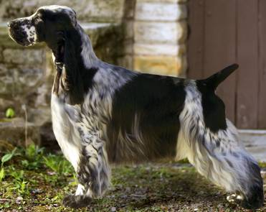 | Ch On Point Gwynllyn Brightwing Legend | Ch. Tuppence Gwynllyn Christmas Legend | Ch. Songbird Christmas Legend | Ch. Jaybriar’s Simon CD
 |  |  |  | Ch Medley Major Motion
 | Ch On Point Gwynllyn Brightwing Legend | Ch. Tuppence Gwynllyn Christmas Legend | Ch. Corwall On Hudson’s Chloe NA | Ch. Stage Door’s Hoist The Flag
 |  |  |  | Trudy
 | Ch On Point Gwynllyn Brightwing Legend | Ch. On Point Legacy | Ch. Ashbrook Apple Jack | Ch Lynann’s Telesis
 |  |  |  | Ch. Headwind’s Kittyhawk
 | Ch On Point Gwynllyn Brightwing Legend | Ch. On Point Legacy | Ch. Caradon Parkway To The Stars | Ch. Gala Glen’s Vatican Soldier
 |  |  |  | Ch. Camberle Rick Rack of Car-Ru
 | Ch. Stage Door’s Hot Tin Roof | Ch. Ainsley’s Johnny Bravo | Ch. Daisymead’s Playboy | Ch. Daisymeaad’s Birth Of The Blues
 |  |  |  | Daisymead’s Main Squeeze
 | Ch. Stage Door’s Hot Tin Roof | Ch. Ainsley’s Johnny Bravo | Ch Faerytail’s Leprechaun | Ch. Ashbrook Aristocrat
 |  |  |  | Ch. Royal Crest Dreamcatcher
 | Ch. Stage Door’s Hot Tin Roof | Ch. Stage Door’s Liza With A “Z” | Ch Edgewood Salute | Ch. Stage Door’s Blushing Groom
 |  |  |  | Edgwood Quitessence
 | Ch. Stage Door’s Hot Tin Roof | Ch. Stage Door’s Liza With A “Z” | Ch. Stage Door’s Gypsy Roseanne | Ch. Stage Door’s Hoist The Flag
 |  |  |  | Trudy
Ch. Ainsley’s Charmed Life  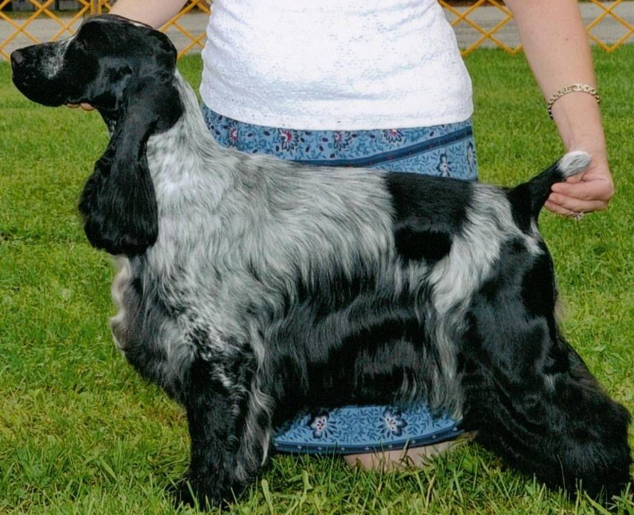 | Ch. Brasswinds Ego Trip | Ch. Ashwind’s Aristocrat | Ch. Lynann’s Telesis | Ch Carachelle Centurion
 |  |  |  | Ch Lynann's Precious Image
 | Ch. Brasswinds Ego Trip | Ch. Ashwind’s Aristocrat | Ch. Headwind’s Kittyhawk | Ch Ashgrove Headwinds Nighthawk
 |  |  |  | Caparcallie Penny Arcade
 | Ch. Brasswinds Ego Trip | Ch. Brasswinds  Blueberry Bash | Ch Lynann’s Infiniti | Ch. Lynann’s Never Ending Story
 |  |  |  | Ch.Cambridge Lynann Doves Cry
 | Ch. Brasswinds Ego Trip | Ch. Brasswinds  Blueberry Bash | Ch. Gentree Blueberry Muffin | Ch Kvammes Hollywood TD
 |  |  |  | Ch. Gentree Midnight Lace
 | Ch. Ainsley’s Lucky Charm | Ch. Portrait Ivywood Middnight Sun | Ch. Sunnyside Skylark Play By Play | Ch. Daisymead’s Playboy
 |  |  |  | Ch. Sunnyside Starry Night
 | Ch. Ainsley’s Lucky Charm | Ch. Portrait Ivywood Middnight Sun | Ch. Ainsley Portrait Badd Desire | Ch. Brasswind’s Windem Rainman
 |  |  |  | Ch. Barrister Ainsley High Style
 | Ch. Ainsley’s Lucky Charm | Ch. Faerytail’s Leprechaun | Ch Ashbrook Aristocrat | Ch. Lynann’s Telesis
 |  |  |  | Ch. Headwind’s Kittyhawk
 | Ch. Ainsley’s Lucky Charm | Ch. Faerytail’s Leprechaun | Ch. Royal Crest Dreamcatcher | Ch. Berridale’s Dream Come True
 |  |  |  | Ch. Stage Door Skylark Finale

