Am.& Aust. Ch. Blueprint Winfree Parti Waggin  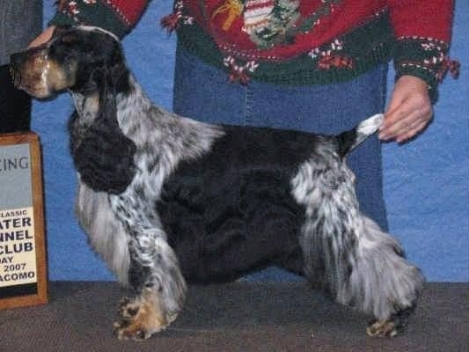 | Ch Lynann's Sirocco | Ch Jaybriar's You're Possessed | Ch Lynann's Legend | Ch Lynann's Infiniti
 |  |  |  | Ch Lynann's Timeless Essence
 | Ch Lynann's Sirocco | Ch Jaybriar's You're Possessed | Ch Jaybriar's Heretic NA ECM | Ch Stage Doors Blushing Groom
 |  |  |  | Ch Jaybriar's Sonnet CD
 | Ch Lynann's Sirocco | Ch Lynann's Timeless Image | Ch Lynann's Telesis | Ch Carachelle Centurion
 |  |  |  | Ch Lynann's Precious Image
 | Ch Lynann's Sirocco | Ch Lynann's Timeless Image | Ch Lynann's Timeless Essence | Ch Tejasvalle Maverick
 |  |  |  | Ch Lynann's Precious Image
 | Ch Blueprint Gift Wrapped | Ch Graffiti Slip to Sandcastle | Ch Sandcastles Skipjack | Ch Lynann's Never Ending Story
 |  |  |  | Ch Mysthill's Sandcastle Debut
 | Ch Blueprint Gift Wrapped | Ch Graffiti Slip to Sandcastle | Ch Sandcastle Subway Graffiti | Ch Glenwood's Sandcastle Deja Vu
 |  |  |  | Ch Southwind Sandcastle Promise
 | Ch Blueprint Gift Wrapped | Ch Brasswinds Blueberry Bash | Ch Lynann’s Infiniti | Ch. Lynann’s Never Ending Story
 |  |  |  | Ch.Cambridge Lynann Doves Cry
 | Ch Blueprint Gift Wrapped | Ch Brasswinds Blueberry Bash | Ch. Gentree Blueberry Muffin | Ch Kvammes Hollywood TD
 |  |  |  | Ch. Gentree Midnight Lace
Ch. Ainsley’s Lucky Charm  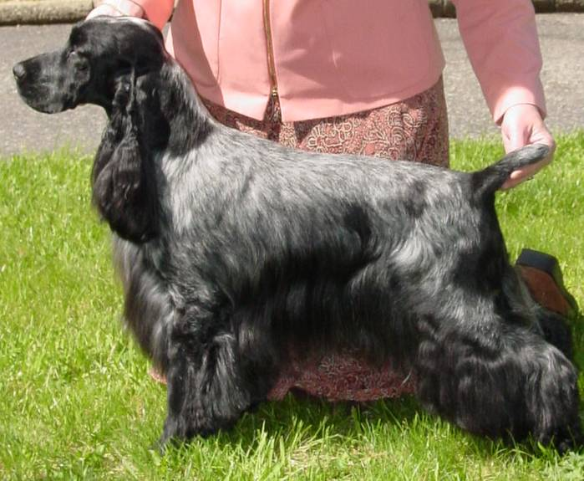 | Ch. Portrait Ivywood Middnight Sun | Ch. Sunnyside Skylark Play By Play | Ch. Daisymead’s Playboy | Ch Daisymead’s Birth Of The Blues
 |  |  |  | Daisymead’s Main Squeeze
 | Ch. Portrait Ivywood Middnight Sun | Ch. Sunnyside Skylark Play By Play | Ch. Sunnyside Starry Night | Ch Stage Door’s Blushing Groom
 |  |  |  | Sunnyside Starlight
 | Ch. Portrait Ivywood Middnight Sun | Ch. Ainsley Portrait Badd Desire | Ch Brasswind’s Windem Rainman | Ch Lynann Infiniti
 |  |  |  | Ch Gentree Blueberry Muffin
 | Ch. Portrait Ivywood Middnight Sun | Ch. Ainsley Portrait Badd Desire | Ch. Barrister Ainsley High Style | Ch Barrister High Sierra
 |  |  |  | Ch. Ainsley’s Back Talk
 | Ch. Faerytail’s Leprechaun | Ch. Ashbrook Aristocrat | Ch. Lynann’s Telesis | Ch Carachelle Centurion
 |  |  |  | Ch Lynann's Precious Image
 | Ch. Faerytail’s Leprechaun | Ch. Ashbrook Aristocrat | Ch. Headwind’s Kittyhawk | Ch Ashgrove Headwinds Nighthawk
 |  |  |  | Caparcallie Penny Arcade
 | Ch. Faerytail’s Leprechaun | Ch. Royal Crest Dreamcatcher WDX | Ch. Berridale’s Dream Come True | Ch Chantilly's Fire and Ice
 |  |  |  | Dicken's Tracey Tupman
 | Ch. Faerytail’s Leprechaun | Ch. Royal Crest Dreamcatcher WDX | Ch. Stage Door Skylark Finale | Ch Bolynn Star Attraction  Ch. Stage Door’s Runaway Bride

