GrCh. Whitfield BluVus Quicksilver ECM CD RN CGC  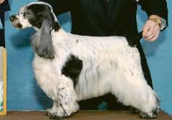 | Ch. Whitfield Windover’s Nova | Ch. Coventry Whitfield Vindicator | Ch. Whitfield’s Crescent Moon ECM WD CGC | Ch. Craigleith Man Of Magic
 |  |  |  | Ch. Gandy Dancer’s Can Dew II ECM
 | Ch. Whitfield Windover’s Nova | Ch. Coventry Whitfield Vindicator | Ch Headwind’s Kittyhawk ECM | Ch. Ashgrove Headwind’s Nighthawk
 |  |  |  | Ch. Capercaille Penny Arcade
 | Ch. Whitfield Windover’s Nova | ChWindover Whitfield’s Luna | Ch. Whitfield’s Crescent Moon ECM WD CGC | Ch. Craigleith Man Of Magic
 |  |  |  | Ch. Gandy Dancer’s Can Dew II ECM
 | Ch. Whitfield Windover’s Nova | ChWindover Whitfield’s Luna | Whitfield’s I’m The One | Ch.Blu Vu Whitfield’s Knockout
 |  |  |  | Ch Whitfield’s Blue Dawn
 | Craigleith New Moon | Craigleith Student Prince | Lynwater Islander | Lynwater Isleman
 |  |  |  | Sh Ch Lynwater Dawn Shimmer
 | Craigleith New Moon | Craigleith Student Prince | Craigleith The Last Waltz | Lochdene Orpheus At Sorbrook
 |  |  |  | Craigleith Merry Widow Waltz
 | Craigleith New Moon | Scomar Sun Maiden At Craigleith | Craigleith A Step In Time | Prince Igor Of Craigleith
 |  |  |  | Craigleith The Snow Maiden
 | Craigleith New Moon | Scomar Sun Maiden At Craigleith | Trimein Colour Me In At Scomar | Lynwater Flute
 |  |  |  | Trimein First Edition
Ch. Ainsley’s Penthouse Sweet  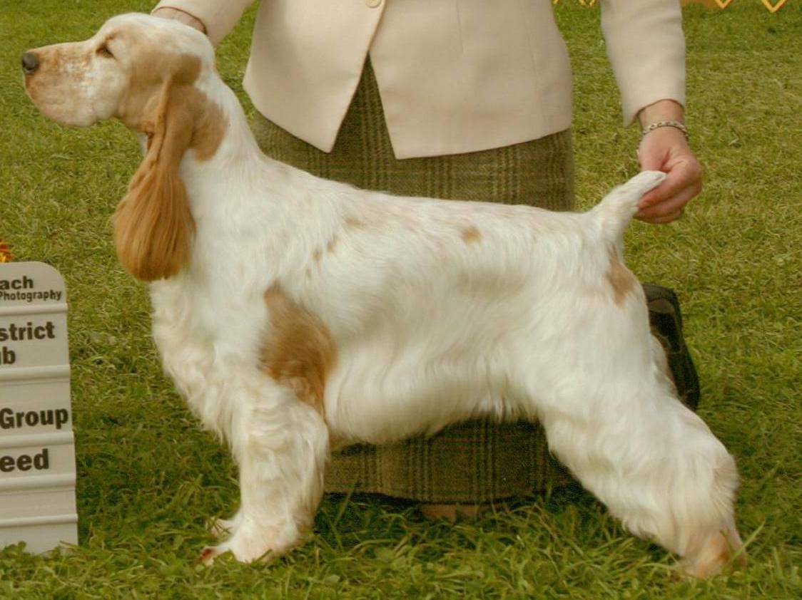 | Ch. Brasswind’s Ego Trip ECM | Ch. Ashbrook Aristocrat ECM | Ch. Lynann’s Telesis ECM | Ch. Carachelle Centurion ECM
 |  |  |  | Ch. . Lynann’s Precious Image ECM
 | Ch. Brasswind’s Ego Trip ECM | Ch. Ashbrook Aristocrat ECM | Ch. Headwinds Kittyhawk ECM | Ch. Ashgrove Headwinds Nighthawk
 |  |  |  | Capercallie Penny Arcade
 | Ch. Brasswind’s Ego Trip ECM | Ch. Brasswinds Blueberry Bash ECM | Ch. Lynann’s Infiniti ECM | Ch Lynann’s Never Ending Story ECM
 |  |  |  | Ch. . Cambridge Lynann Doves Cry
 | Ch. Brasswind’s Ego Trip ECM | Ch. Brasswinds Blueberry Bash ECM | Ch. Gentree Blueberry Muffin ECM | Ch Kvammes Hollywood TD
 |  |  |  | Ch. Gentree Midnight Lace
 | Ch. Ainsley’s The One’s One | Am & Can Ch. Ainsley’s Johnny Bravo ECM | Ch. Daisymead’s Playboy ECM | Ch Daisymead’s Birth Of The Blues ECM
 |  |  |  | Daisymead’s Main Squeeze
 | Ch. Ainsley’s The One’s One | Am & Can Ch. Ainsley’s Johnny Bravo ECM | Ch. Faerytail’s Leprechaun | Ch. Ashbrook Aristocrat ECM
 |  |  |  | Ch. Royal Crest Dreamcatcher WDX ECM
 | Ch. Ainsley’s The One’s One | Ainsley’s Jazzy Blue Bonnet | Boxhill Bombardier | Ch. Ainsley Boxhill Back N Black
 |  |  |  | Boxhill Body Double
 | Ch. Ainsley’s The One’s One | Ainsley’s Jazzy Blue Bonnet | Ch Ainsley’s Krime Of Passion | Ch. Ainsley’s Taylor McMurphy
 |  |  |  | Ch Portrait Ainsley Blu Lace

