Ch. Ainsley’s Double Agent  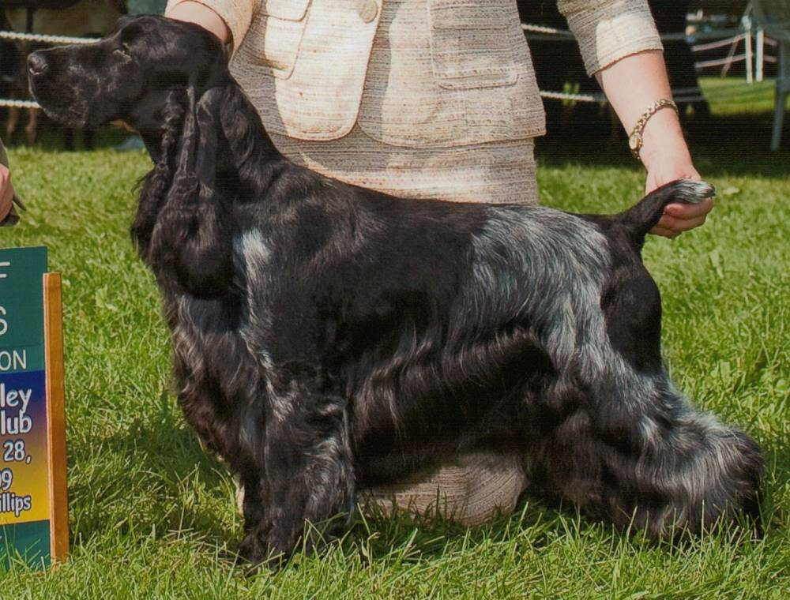 | Ch Ivywood Double Jeopardy | Ch. Ainsley Boxhill Back N Black | Ch. Boxhill’s Blackjack | Ch. Bellfower Boxhill Jackpot
 |  |  |  | Ch Boxhill’s Bewitched
 | Ch Ivywood Double Jeopardy | Ch. Ainsley Boxhill Back N Black | Ch. Ainsley’s Back Talk | Ch. Amawalk Wildwood Honor Guard
 |  |  |  | Ch. Kedgwick Goodtime Charlie CD
 | Ch Ivywood Double Jeopardy | Ch. Ainsley’s Perfect Krime | Ainsley’s Taylor McMurphy | Ch Kedgwick Split Decision
 |  |  |  | Ch. Ainsley’s Cara Of Gold Leaf
 | Ch Ivywood Double Jeopardy | Ch. Ainsley’s Perfect Krime | Ch. Portrait’s Ainsley Blu Lace | Ch Kedgwick Split Decision
 |  |  |  | Ch. Majick Annie’s In The Pink
 | Ch. Ainsley’s Lucky Charm | Ch. Portrait Ivywood Middnight Sun | Ch. Sunnyside Skylark Play By Play | Ch. Daisymead’s Playboy
 |  |  |  | Ch. Sunnyside Starry Night
 | Ch. Ainsley’s Lucky Charm | Ch. Portrait Ivywood Middnight Sun | Ch. Ainsley Portrait Badd Desire | Ch. Brasswind’s Windem Rainman
 |  |  |  | Ch. Barrister Ainsley High Style
 | Ch. Ainsley’s Lucky Charm | Ch. Faerytail’s Leprechaun | Ch Ashbrook Aristocrat | Ch. Lynann’s Telesis
 |  |  |  | Ch. Headwind’s Kittyhawk
 | Ch. Ainsley’s Lucky Charm | Ch. Faerytail’s Leprechaun | Ch. Royal Crest Dreamcatcher | Ch. Berridale’s Dream Come True
 |  |  |  | Ch. Stage Door Skylark Finale
Ch. Cobblestone Tuscany Veuve Clicquot NJW | Ch. Edgewood Vendetta | Ch. Lynann’s Sentinel | Ch. Ch. Lynann’s Telesis | Ch. Carachelle Centurion
 |  |  |  | Ch. Lynann’s Precious Image
Ch. Cobblestone Tuscany Veuve Clicquot NJW | Ch. Edgewood Vendetta | Ch. Lynann’s Sentinel | Ch. Lynann’s Timeless Essence | Ch. Tejasvalle Maverick
 |  |  |  | Ch. Lynann’s Precious Image
Ch. Cobblestone Tuscany Veuve Clicquot NJW | Ch. Edgewood Vendetta | Ch. Edgewood Unforgettable | Ch Edgewood Salute | Ch. Stage Door’s Blushing Groom
 |  |  |  | Edgewood Quintessence
Ch. Cobblestone Tuscany Veuve Clicquot NJW | Ch. Edgewood Vendetta | Ch. Edgewood Unforgettable | Ch. Edgewood Remembrance | Ch. Edgewood Fan Tan
 |  |  |  | Ch. Edgewood Memento
Ch. Cobblestone Tuscany Veuve Clicquot NJW | Ch. Cobblestone’s Coco Chanel CD RN NAJ | Ch. Portrait Ivywood Middnight Sun | Ch. Sunnyside Skylark Play By Play | Ch. Daisymead’s Playboy
 |  |  |  | Ch. Sunnyside Starry Night
Ch. Cobblestone Tuscany Veuve Clicquot NJW | Ch. Cobblestone’s Coco Chanel CD RN NAJ | Ch. Portrait Ivywood Middnight Sun | Ch. Ainsley Portrait Badd Desire | Ch. Brasswind’s Windem Rainman
 |  |  |  | Ch. Barrister Ainsley High Style
Ch. Cobblestone Tuscany Veuve Clicquot NJW | Ch. Cobblestone’s Coco Chanel CD RN NAJ | Ch. Faerytails As If By Magic CDX JH OJP | Ch Ashbrook Aristocrat | Ch. Lynann’s Telesis
 |  |  |  | Ch. Headwind’s Kittyhawk
Ch. Cobblestone Tuscany Veuve Clicquot NJW | Ch. Cobblestone’s Coco Chanel CD RN NAJ | Ch. Faerytails As If By Magic CDX JH OJP | Ch. Royal Crest Dreamcatcher | Ch. Berridale’s Dream Come True
 |  |  |  | Ch. Stage Door Skylark Finale

