Ch. Winsome Gwynllyn Simply Surreal  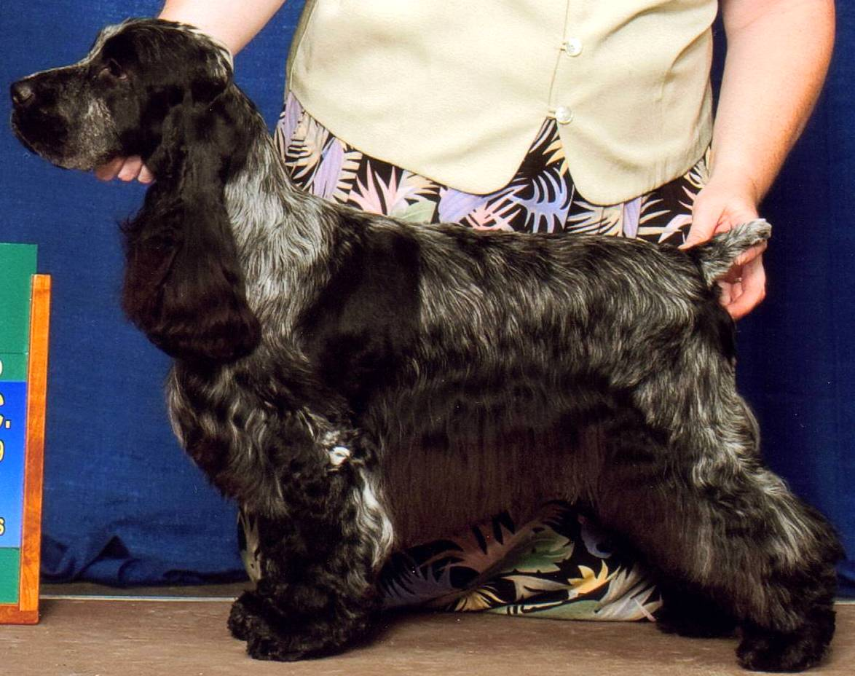 | Ch. Shambrio’s Virtual Reality | Am & Can Ch. Zytut Shambrio Catch Me If U Can | Ch. Ashgrove Aramis | Westerner Waiting In The Wings
 |  |  |  | Ch. Ashgrove Captivating
 | Ch. Shambrio’s Virtual Reality | Am & Can Ch. Zytut Shambrio Catch Me If U Can | Ch. Shambrio’s Poetry N’ Motion | Ch.Shambrio’s Midnight Marauder
 |  |  |  | Ch. Dickens Becky Morgan
 | Ch. Shambrio’s Virtual Reality | Am & Can Ch. Telltale Shambrio’s Chigadee | Ch. Edgewood Vendetta ECM | Ch. Lynann’s Sentinel
 |  |  |  | Ch. Edgewood Unforgettable
 | Ch. Shambrio’s Virtual Reality | Am & Can Ch. Telltale Shambrio’s Chigadee | Ch. Winfree’s Dixie Chick | Ch. McMurphy Fieldstone Foster NA NAJ ECM
 |  |  |  | Winfree’s Tuson’s Finer Things
 | Ch. Winsome Gwynllyn Blissfully Blu | Ch. Royal Crest’s Apple Jack | Ch. Springhill Slapjack MX MXJ WD ECM | Ch Bellflower Boxhill Jackpot ECM
 |  |  |  | Ch. Fieldstone Springhill Ember UD ECM
 | Ch. Winsome Gwynllyn Blissfully Blu | Ch. Royal Crest’s Apple Jack | Ch. Stagedoor Skylark Finale | Ch Bolynn Star Attraction ECM
 |  |  |  | Ch. Stage Door’s Runaway Bride ECM
 | Ch. Winsome Gwynllyn Blissfully Blu | Ch. Winsome Heirloom of Gwynllyn WD | Ch. Tuppence Gwynllyn Christmas Legend ECM | Ch. Songbird Clever Trever ECM
 |  |  |  | Ch. Cornwall-On-Hudson’s Chloe
 | Ch. Winsome Gwynllyn Blissfully Blu | Ch. Winsome Heirloom of Gwynllyn WD | Ch. Valley Hill Winsome Blu Lace | Ch. Songbird Clever Trever ECM
 |  |  |  | Ch. Majick Vally Hill Cody
Ch. Ainsley’s Lucky Star  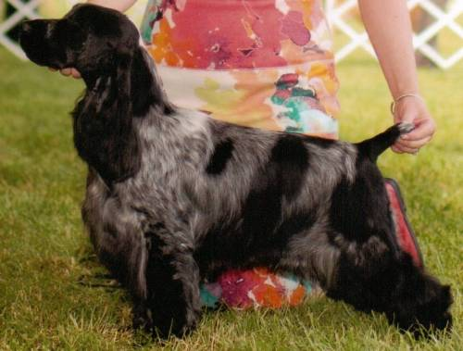 | Am.& Aust. Ch. Blueprint Winfree Parti Waggin ECM | Ch Lynann's Sirocco ECM | Ch Jaybriar's You're Possessed ECM | Ch Lynann's Legend ECM
 |  |  |  | Ch Jaybriar's Heretic NA ECM
 | Am.& Aust. Ch. Blueprint Winfree Parti Waggin ECM | Ch Lynann's Sirocco ECM | Ch Lynann's Timeless Image | Ch Lynann's Telesis ECM
 |  |  |  | Ch Lynann's Timeless Essence ECM
 | Am.& Aust. Ch. Blueprint Winfree Parti Waggin ECM | Ch Blueprint Gift Wrapped ECM | Ch Graffiti Slip to Sandcastle ECM | Ch Sandcastles Skipjack ECM
 |  |  |  | Ch Sandcastle Subway Graffiti ECM
 | Am.& Aust. Ch. Blueprint Winfree Parti Waggin ECM | Ch Blueprint Gift Wrapped ECM | Ch Brasswinds Blueberry Bash | Ch Lynann’s Infiniti ECM
 |  |  |  | Ch. Gentree Blueberry Muffin
 | Ch. Ainsley’s Lucky Charm | Ch. Portrait Ivywood Middnight Sun ECM | Ch. Sunnyside Skylark Play By Play ECM | Ch. Daisymead’s Playboy ECM
 |  |  |  | Ch. Sunnyside Starry Night
 | Ch. Ainsley’s Lucky Charm | Ch. Portrait Ivywood Middnight Sun ECM | Ch. Ainsley Portrait Badd Desire | Ch Brasswind’s Windem Rainman
 |  |  |  | Ch. Barrister Ainsley High Style
 | Ch. Ainsley’s Lucky Charm | Ch. Faerytail’s Leprechaun | Ch. Ashbrook Aristocrat ECM | Ch. Lynann’s Telesis ECM
 |  |  |  | Ch. Headwind’s Kittyhawk ECM
 | Ch. Ainsley’s Lucky Charm | Ch. Faerytail’s Leprechaun | Ch. Royal Crest's Dreamcatcher JH WDX ECM | Ch. Berridale’s Dream Come True ECM
 |  |  |  | Ch. Stage Door Skylark Finale

