Ch. Winsome Gwynllyn Brazenly Blu  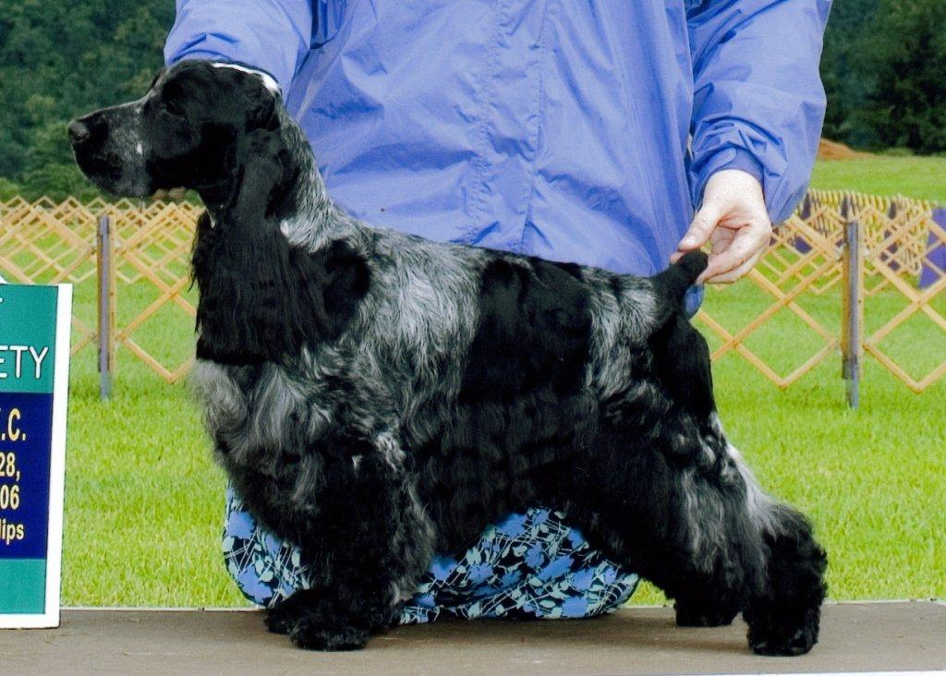 | Ch. Royal Crest’s Apple Jack ECM | Ch. Springhill Slapjack MX MXJ WD ECM | Ch. Bellflower Boxhill Jackpot ECM | Ch. Successor Of Sorts ECM
 |  |  |  | Ch. Bellflower Eloquence ECM
 | Ch. Royal Crest’s Apple Jack ECM | Ch. Springhill Slapjack MX MXJ WD ECM | Ch Fieldstone Springhill Ember UD ECM | Ch. Edgewood Play With Fire CD TD WC ECM
 |  |  |  | Ch. Harmsway’s Desiree
 | Ch. Royal Crest’s Apple Jack ECM | Ch. Stage Door Skylark’s Finale | Ch. Bolynn Star Attraction ECM | Ch. Kenobo Capricorn ECM
 |  |  |  | Ch. Bolynn N Harmsways Bedazzled
 | Ch. Royal Crest’s Apple Jack ECM | Ch. Stage Door Skylark’s Finale | Ch. Stage Door’s Runaway Bride ECM | Ch.Lynann’s Risky Business ECM
 |  |  |  | Ch Log Tavern Stage Door Debut ECM
 | Ch. Winsome Heirloom Of Gwynllyn WD | Ch Tuppence Gwynllyn Christmas Legand ECM | Ch. Songbird Clever Trever ECM | Ch. Jaybriar’s Simon CD ECM
 |  |  |  | Ch. Medley Major Motion
 | Ch. Winsome Heirloom Of Gwynllyn WD | Ch Tuppence Gwynllyn Christmas Legand ECM | Ch. Cornwall-On-Hudson’s Chloe | Ch Stage Door’s Hoist The Flag
 |  |  |  | Trudy
 | Ch. Winsome Heirloom Of Gwynllyn WD | Ch. Valley Hill Winsome Blu Lace WDX NA ECM | Ch. Songbird Clever Trever ECM | Ch. Jaybriar’s Simon CD ECM
 |  |  |  | Ch. Medley Major Motion
 | Ch. Winsome Heirloom Of Gwynllyn WD | Ch. Valley Hill Winsome Blu Lace WDX NA ECM | Ch. Majick Valley Hill Cody | Ch. Pennwood Foxhollow I’m Mr Blue
 |  |  |  | Ch. Barrister Regency Romance
Ch. Ainsley’s Penthouse Sweet  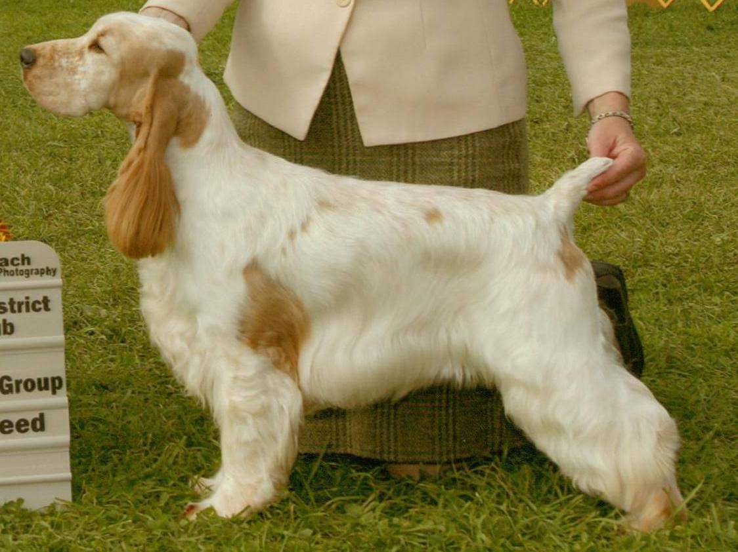 | Ch. Brasswind’s Ego Trip ECM | Ch. Ashbrook Aristocrat ECM | Ch. Lynann’s Telesis ECM | Ch. Carachelle Centurion ECM
 |  |  |  | Ch. . Lynann’s Precious Image ECM
 | Ch. Brasswind’s Ego Trip ECM | Ch. Ashbrook Aristocrat ECM | Ch. Headwinds Kittyhawk ECM | Ch. Ashgrove Headwinds Nighthawk
 |  |  |  | Capercallie Penny Arcade
 | Ch. Brasswind’s Ego Trip ECM | Ch. Brasswinds Blueberry Bash ECM | Ch. Lynann’s Infiniti ECM | Ch Lynann’s Never Ending Story ECM
 |  |  |  | Ch. . Cambridge Lynann Doves Cry
 | Ch. Brasswind’s Ego Trip ECM | Ch. Brasswinds Blueberry Bash ECM | Ch. Gentree Blueberry Muffin ECM | Ch Kvammes Hollywood TD
 |  |  |  | Ch. Gentree Midnight Lace
 | Ch. Ainsley’s The One’s One | Am & Can Ch. Ainsley’s Johnny Bravo ECM | Ch. Daisymead’s Playboy ECM | Ch Daisymead’s Birth Of The Blues ECM
 |  |  |  | Daisymead’s Main Squeeze
 | Ch. Ainsley’s The One’s One | Am & Can Ch. Ainsley’s Johnny Bravo ECM | Ch. Faerytail’s Leprechaun | Ch. Ashbrook Aristocrat ECM
 |  |  |  | Ch. Royal Crest Dreamcatcher WDX ECM
 | Ch. Ainsley’s The One’s One | Ainsley’s Jazzy Blue Bonnet | Boxhill Bombardier | Ch. Ainsley Boxhill Back N Black
 |  |  |  | Boxhill Body Double
 | Ch. Ainsley’s The One’s One | Ainsley’s Jazzy Blue Bonnet | Ch Ainsley’s Krime Of Passion | Ch. Ainsley’s Taylor McMurphy
 |  |  |  | Ch Portrait Ainsley Blu Lace

